#221
Product Description: |  |  |  |  |  |  |  |  |  |  |  |  |  |  |  |  |  |  | Product Film Type:
Product Generic ID#: |  | C1U0050SB16/21/49 |  |  |  |  |  |  |  |  |  |  |  |  |  |  |  |  | 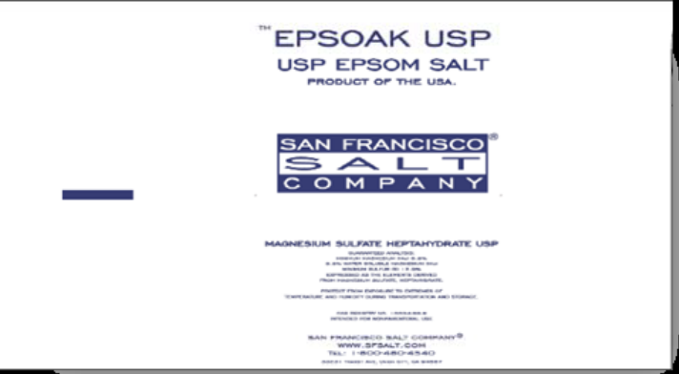
Product Grade: |  | USP
Product Screen: |  | Screened (no dust)
Packaging Weight: |  | 50lb
Pallet Configuration: |  | According to item ID
Other:
Quality:
 | - Samples to be taken |  |  |  |  |  |  | Retained for:
 | - Testing Required |  |  |  |  |  |  | Testing for:
 | - Quality Release |  |  |  |  |  |  | Criteria Needed: |  |  |  |  |  | Quality inspection to ensure that there are no leaks or imperfect seams (that could lead to leakage).  Quality will determine the extent of inspection.
Production/Packaging:
 | - Shrink Wrap |  |  |  | - Liners Required |  |  |  |  |  |  |  |  |  |  | - Heat Treated Pallets |  |  |  |  |  |  |  |  |  |  | - Stickers Required
 | - Extra Placard or Tag Required: |  |  |  |  |  |  |  |  | Description:
 | - Other Requirements: |  |  |  |  |  | Description: |  |  |  | Stacked according to Item ID.

Shipping:
 | - General |  |  | - Air Bags |  |  |  |  |  |  |  |  | - Double Wrap |  |  |  |  |  |  |  |  |  |  | - Corner Boards |  |  |  | - Block & Brace
 | - Must have Quality Approval signature before loading: |  |  |  |  |  |  |  |  |  |  |  |  |  |  |  |  |  |  | Reason: |  | Quality inspection to ensure that there are no leaks or imperfect seams (that
 | could lead to leakage). Quality will  determine the extent of inspection. |  |  |  |  |  |  |  | Signature: |  |  |  |  |  |  |  |  |  |  |  |  |  |  |  |  |  |  | Date:
 | - Must have Management Approval signature before loading: |  |  |  |  |  |  |  |  |  |  |  |  |  |  |  |  |  |  |  | Reason:
 |  |  |  |  |  |  |  |  | Signature: |  |  |  |  |  |  |  |  |  |  |  |  |  |  |  |  |  |  | Date:
 | - Other:
Change Information: |  |  | Added Quality inspection.

